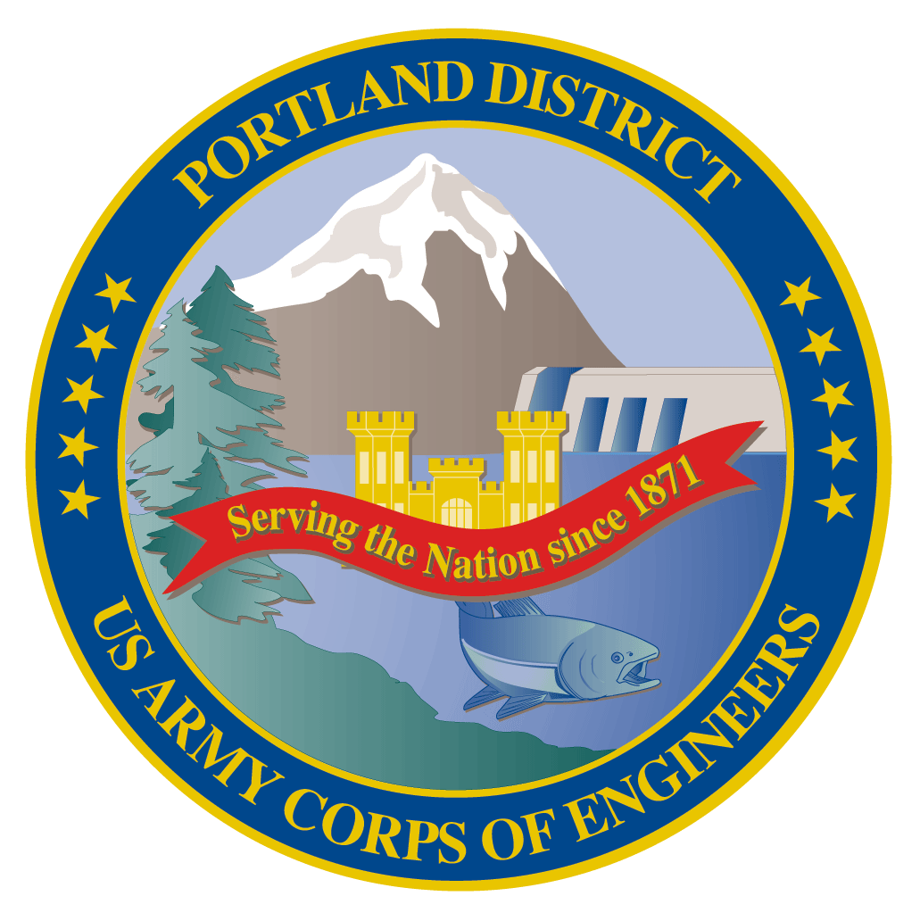Fish Facility Design Review Work Group (FFDRWG)

USACE, Portland District

# May 2021 Meeting Agenda

May 6, 2021 09:00-11:00

Join Meeting: <https://usace1.webex.com/usace1/j.php?MTID=m5c365c1bf762dad74cbaa2985e8e04fb>

Meeting password: FFDRwG2021!

*(*if using your phone for audio, log in through Webex and have the meeting call you)*

Join by phone (audio only, no Webex): (844) 800-2712 | Access Code: 199 571 1422

## Introductions

FFDRWG members:

**BPA**

Scott Bettin

Kim Johnson

Siena Lopez-Johnston

Christine Petersen

Greg Smith

Leah Sullivan

**NOAA**

Blane Bellerud

Gabriel Brooks

Trevor Conder

Kinsey Frick

Claire McGrath

Josie Thompson

Logan Negherbon

**USFWS**

Dave Swank

**States**

Erick Van Dyke (ODFW)

Charles Morrill (WDFW)

**CRITFC/Tribes**

Tom Lorz (CRITFC)

Blaine Parker (CRITFC)

Tom Skiles (CRITFC)

Casey Baldwin (CTCR)

Michael Karnosh (CTGR)

Lawrence Schwabe (CTGR)

Torey Wakeland (CTGR)

Aaron Jackson (CTUIR)

Ralph Lampman (YN)

**NPCC**

Leslie Bach

Kris Homel

**FPC**

Erin Cooper

**PSMFC**

Alan Brower

Darren Chase

Roger Clark

Mark Leonard

Scott Livingston

Nicole Tancreto

Don Warf

**CENWD**

Doug Baus

Tim Dykstra

Dan Feil

Mike Langeslay

Cindy Studebaker

Sean Tackley

Lisa Wright

**CENWW**

Karl Anderson

Chris Peery

Marvin Shutters

Denise Griffith

**CENWP-OD**

Andrew Derugin

Rebecca Cates

Jeanette Wendler

Bob Cordie

Jeffrey Randall

Scott Fielding

Eric Grosvenor

Michael Lotspeich

Tammy Mackey

Darren Gallion

Nathan McClain

Robert Wertheimer

**CENWP-PM**

Jim Adams

Eric Bluhm

Ian Chane

Jeff Hicks

Steve Sipe

Bob Winters

Brad Eppard

David Griffith

Fenton Khan

Rachel Laird

Jake Macdonald

Rich Piaskowski

Jon Rerecich

Ida Royer

David Trachtenbarg

Jeremiah Woodard

Erin Kovalchuk

**CENWP-ENC**

Adam White

Brandt Bannister

Bridget Bell

Jonathon Brink-Roby

Shari Dunlop

Laurie Ebner

Curtis Lipski

Chris Motti

Steve Schlenker

Max Wilson-Fey

Mehdi Roshani

## Action items from last meeting

* None

## Topics for FFDRWG Discussion/Review/Coordination

* TDA AWS Trash Rake – Erin Kovalchuk (PM), Mehdi Roshani (TL), Jon Rerecich (FC)
  + Introduce new PM and TL
* BON Washington Shore control section redesign – Bob Winters (PM), Shari Dunlop (TL), Andrew Derugin (FC)
  + Update on scoping progress
* BON Second Powerhouse FGE – Jim Adams (PM), Bridget Bell (TL), Jon Rerecich (FC)
  + Schedule update
* BON spillway rock removal mitigation – Jeremiah Woodard (PM), Max Wilson-Fey (TL), Andrew Derugin (FC)
  + Distinction between “removal” and “mitigation” (2 PDT’s)
  + Model report status update
* BON spillway survival
  + Next steps to identify structural components and/or operations that might negatively impact survival
* BON Ice & Trash PIT detection

## Written project updates

* JDA turbine rehab – Steve Sipe (PM), Curtis Lipski (TL), Jon Rerecich (FC)
* JDA North Fish Ladder Variable Width Weir improvement – Eric Bluhm (PM), Eric Grosvenor (JDA), Jacob Macdonald (FC)
* JDA North Fish Ladder LPS water supply upgrade – Eric Bluhm (PM), Adam White (TL), Jacob Macdonald (FC)
* JDA South Ladder entrance improvements (rounded crest, slot filler) – Eric Bluhm (PM), Adam White (TL), Jacob Macdonald (FC)

* TDA East Fish Ladder junction pool LPS – Eric Bluhm (PM), Adam White (TL), Jacob Macdonald (FC)
* TDA East Fish Ladder control section weir modifications for lamprey – Eric Bluhm (PM), Adam White (TL), Jacob Macdonald (FC)
* BON LPS pump upgrades – Bob Winters (PM), Ben Hausmann (TL), Andrew Derugin (FC)
* BON Bradford Island B-Branch entrance improvements (variable width entrance weir, bollards, and transition pool LPS) – Bob Winters (PM), Adam White (TL), Andrew Derugin (FC)
* BON Bradford Island Ladder extensive minor modifications to serpentine section for lamprey – Bob Winters (PM), Adam White (TL), Andrew Derugin (FC)
* BON Cascades Island LPS flume modifications – Bob Winters (PM), Ben Hausmann (TL), Andrew Derugin (FC)
* BON Cascades Island upper leads – Bob Winters (PM), Andrew Derugin (TL), Andrew Derugin (FC)
* BON Washington Shore junction pool LPS – Bob Winters (PM), Adam White (TL), Andrew Derugin (FC)

Next meeting: June 3rd @ 09:00

Fish Facility Design Review Work Group (FFDRWG)

USACE, Portland District

Project Update

Date Prepared/Updated: 2021-05-03

# TDA AWS trash rake

|  |  |
| --- | --- |
| Project Identifier: | P2 # |
| Project Manager (PM): | Erin Kovalchuk (CENWP-PMF)  *Erin.H.Kkovalchuk@usace.army.mil* |
| Technical Lead (TL): | Mehdi Roshani (CENWP-ENC)  *Mehdi.Roshani@usace.army.mil* |
| FFDRWG Coordination (FC): | Jon Rerecich (CENWP-PME)  *Jonathan.G.Rerecich@usace.army.mil* |

## Project Description

## This project is to evaluate alternatives to remove debris from The Dalles Dam Auxiliary Water Supply (AWS) trash rack. Debris build-up on the rack currently causes high head differential across the rack.

## Project Schedule

TBD

## Current Status

New Startup. PM and TL have been assigned. Kickoff meeting and site visit are being scheduled and team members are being assigned.

## Topics for FFDRWG Review/Coordination

None currently. PDT will solicit FFDRWG review during the Engineering Design Report (EDR) process.

Fish Facility Design Review Work Group (FFDRWG)

USACE, Portland District

Project Update

Date Prepared/Updated: 2021-03-30

# BON Second Powerhouse FGE

|  |  |
| --- | --- |
| Project Identifier: | P2 # |
| Project Manager (PM): | Jim Adams (CENWP-PMF)  *James.R.Adams@usace.army.mil* |
| Technical Lead (TL): | Bridget Bell (CENWP-ENC)  *Bridget.M.Bell@usace.army.mil* |
| FFDRWG Coordination (FL): | Jon Rerecich (CENWP-PME)  *Jonathan.G.Rerecich@usace.army.mil* |

## Project Description

Steel plates were installed in all units in the A and B gatewells to restrict flow. During routine inspections, however, it became apparent that the anchoring system for the steel plates was inadequate. In effect, the nuts and anchoring bolts holding down the plates had come lose, posing the risk that the plates could detach and potentially take out a unit. All flow restriction plates were removed from the units.

A concrete corbel will be installed in the same location as the flow control plates with the design goal to achieve similar gatewell hydraulic conditions as the flow control plates. This new concrete corbel has been designed to meet the flow criteria established and tested for the previous flow restrictor plates to meet the hydraulic and biological goals.

## Project Schedule

Awarded 21 December 2020 to Northbank Civil and Marine. Notice to proceed 29 December 2020.

|  |  |  |  |  |
| --- | --- | --- | --- | --- |
| CLIN | Status | Description | Award/Exercise Date | Construction Execution Window |
| 1 | Mandatory | Mobilization/Demobilization | December 2020 Award |  |
| 2 | Mandatory | Unit 15 Construction | December 2020 Award | February 2021-April 2021 |
| 3 | Optional | Second Mob/Demob and Unit 11 Construction | Sept. 30, 2021 | Dec 2021-Feb 2022 |
| 4 | Optional | 2 Additional Units | Sept. 30, 2021 | Extend through May 2022 |
| 5 | Optional | 2 Additional Units | Nov. 30, 2021 | Extend through August 2022 |
| 6 | Optional | 2 Additional Units (Unit 18 + 1 more Unit) | Nov. 30, 2021 | Extend through February 2023 |

## Current Status

* Construction in unit 15 is underway and on track. Unit 15 is on the outage schedule March 1-April 20. The contract states the unit must be completed by April 15th.
* Hydraulic Testing Spring 2021 – During March contract negotiations with NWP, the A/E contractor expressed concerns in meeting the testing deadline and deliverables due to procurement of equipment, preparation/calibration of equipment, and staffing limitations. Hydraulic testing will not occur this year.
* Hydraulic tests will be needed next spring to meet the upper 1% test range of 18.0-18.5 kcfs.
* Impacts to the B2FGE concrete work contract are being evaluated. The concrete work will be delayed by one year.
* Rerecich owes Lorz a beer.

## Topics for FFDRWG Review/Coordination

None currently.

Fish Facility Design Review Work Group (FFDRWG)

USACE, Portland District

Project Update

Date Prepared/Updated: 2021-03-30

# BON Washington Shore control section redesign

|  |  |
| --- | --- |
| Project Identifier: | P2 # 492401 |
| Project Manager (PM): | Bob Winters (CENWP-PM-FP)  *Robert.Winters@usace.army.mil* |
| Technical Lead (TL): | Shari Dunlop (CENWP-ENC)  *Shari.L.Dunlop@usace.army.mil* |
| FFDRWG Coordination (FC): | Andrew Derugin (CENWP-PME)  *Andrew.G.Derugin@usace.army.mil* |

## Project Description

“…modify the serpentine-style flowcontrol sections of Bonneville Dam’s Washington Shore and Bradford Island fish ladders,converting them to Ice Harbor-style vertical slot with submerged orificesconfigurations. Thiswould improve passage conditions for adult lamprey and likely reduce stress and delay for adultsalmon, steelhead, and bull trout. All full-duplex passive integrated transponder (PIT) arrays currently located in the control sections of these ladders would be replaced in kind or improved to maintain or enhance current levels of detection of PIT-tagged anadromous fish.”

***-January 2020 CRS BA § 2.5, pg. 2-85****.*

## Project Schedule

TBD

## Current Status

A problem with PIT tag antennas coupled with actuated sill gates in the vertical slots was identified during scope development. The PDT is currently performing a screening-level investigation to determine if the required flow control can be achieved without adjustable-height sill gates. Based on the outcome, the design may include replacement of the PIT tag antennas in the control section or may require identifying an alternate location for the existing PIT tag antenna array.

## Topics for FFDRWG Review/Coordination

None currently. PDT will coordinate with FFDRWG after we have a better understanding of the underlying design assumptions.

Fish Facility Design Review Work Group (FFDRWG)

USACE, Portland District

Project Update

Date Prepared/Updated: 2021-05-04

# BON Spillway Rock Removal Mitigation

|  |  |
| --- | --- |
| Project Identifier: | P2 # 470163 |
| Project Manager (PM): | Jeremiah Woodard (CENWP-PMF-P)  *Jeremiah.J.Woodard@usace.army.mil* |
| Technical Lead (TL): | Max Wilson-Fey (CENWP-ENC-HD)  *Max.P.Wilson-Fey@usace.army.mil* |
| FFDRWG Coordination (FC): | Jacob Macdonald (CENWP-PME)  *Jacob.Macdonald@usace.army.mil* |

## Project Description

P2# 470163 includes two PDT’s distinguished by their funding source. The Bonneville spillway rock *removal* PDT is responsible for physically removing rocks from the stilling basin/spillway annually (or as needed). Rock removal is jointly funded by Corps O&M and BPA Expense funding and coordinated in the FPOM regional forum. The Bonneville spillway rock removal *mitigation* PDT is responsible for identifying, designing, and constructing a long-term solution that would prevent rocks from migrating into the stilling basin. Rock removal mitigation is jointly funded by Corps O&M and BPA Capital funding and coordinated in the FFDRWG regional forum.

Currently emergency contracts are placed most years to physically remove rocks from the stilling basin (FPOM). This FFDRWG project is to determine whether a structural alternative can be identified to reduce the frequency of physical rock removal by preventing rocks from moving into the stilling basin in the first place. Alternatives will be evaluated based on factors such as their ability to prevent rock movement, cost, and ease of construction.

## Project Schedule

Complete modeling report: May 2021. Distribute modeling report for FFDRWG review: June 2021

Distribute 60% Phase 1a report for FFDRWG review: August 2021. Complete Phase 1a report: September 2021

## Current Status

A modeling report summarizing NWP CFD and ERDC physical model results will be ready for regional review in June. Draft is complete, pending internal review. CFD modeling looked at extending the continuous baffle block currently downstream of bays 10-17 past bay 9, a barrier on the ramp, and raising the whole ramp. Physical modeling looked at extending the solid baffle block downstream of bays 10-18 past bay 9 and a barrier on the ramp. Raising the whole ramp produced high velocities along the shorelines in the CFD model and was not carried forward to the physical model.

## Topics for FFDRWG Review/Coordination

PDT will distribute the model report for FFDRWG review around the time of our next meeting (3-June).

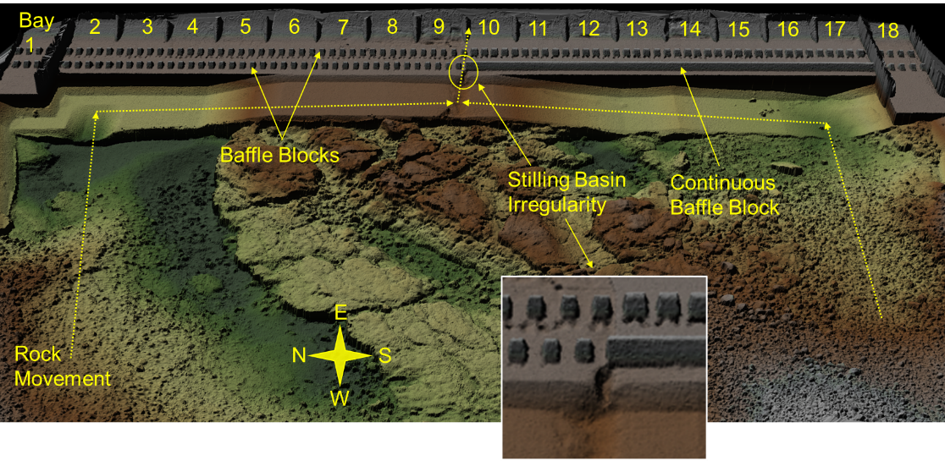

**Fish Facility Design Review Work Group (FFDRWG)**

**USACE, Portland District**

**Project Update**

Date Prepared/Updated: 2021-04-01

# JDA Turbine Rehab

|  |  |
| --- | --- |
| Project Identifier: | P2 # |
| Project Manager (PM): | Steve Sipe (CENWP-PMF-P)  *Steven.C.Sipe@usace.army.mil* |
| Technical Lead (TL): | Curtis Lipski (CENWP-ENC-HD)  *Curtis.L.Lipski@usace.army.mil* |
| FFDRWG Coordination (FL): | Jon Rerecich (CENWP-PME)  *Jonathan.G.Rerecich@usace.army.mil* |

## Project Description

The purpose of this project is to address reliability concerns and maximize production of hydroelectric power at JDA, which includes electrical energy production and electrical grid ancillary services while at the same time, improving survival of fish passing through the turbines. Maximum production of hydroelectric power at JDA will be realized through increased reliability and increased efficiency. Reliability improvements will be realized through a combination of replacement and refurbishment of powertrain equipment to include, but not limited to, turbine runners, shafting, generators, isophase bus, breakers, switches, and transformers. Efficiency improvements will be realized through increased turbine efficiencies associated with new turbine runners and other modifications to the turbines.

The purpose of this project is also to increase survival of turbine passed fish. Increased survival of turbine passed fish will be realized through developing state-of-art hydroelectric turbines to obtain improved fish passage survival through the turbines. The design of the state-of-the-art turbines will be an iterative and collaborative process that focuses on fish-friendly design features and criteria. This iterative and collaborative design process will be similar to the ongoing Ice Harbor L&D turbine runner replacement design and upcoming McNary L&D turbine runner replacement in NWW. Phase 1A recommendations include replacing up to 14 units with combination fixed blade & adjustable blade to obtain improved fish passage survival through the turbines.

## Project Schedule

|  |  |  |
| --- | --- | --- |
| Phase 1 Short Term Schedule | Start | Finish |
| 30% DDR/P&S review | 3/12/2020 | 4/1/2020 |
| 60% DDR/P&S review | 8/28/2020 | 9/18/2020 |
| 90% DDR/P&S review | 9/21/2021 | 2/18/2022 |
| BCOES review | 1/24/2022 | 11/11/2022 |

|  |  |
| --- | --- |
| Overall Schedule Milestones | Date |
| Contract award | October 2024 |
| Collaborative design process Model testing | 2024-2029 |
| First unit installation | 2031-2033 |
| Unit installation complete | 2040-2045 |

## Current Status

* Final VE study report due Feb. 19, 2021
* The 1:25 scale physical observational turbine model rehab and relocation is complete. The model will be used to inform the development of the Phase 1 Plans and Specifications package, to document the hydraulic conditions that affect the biological performance of the existing JDA turbines, and to support the collaborative and iterative design process in Phase 2. ERDC baseline model validation testing with the existing runner has been scheduled for last week and this week. Baseline model data collection for Test Series 1 will be occurring until May 2021 at which time ERDC is scheduled to transition back to McNary. This task includes preparation of a data report documenting the runs performed, results, conclusions, and recommendations. Runner evaluation tests will need to carry over to Test Series 2 (not yet scoped), which is expected to occur in late 2021 or early 2022.
* Tailrace flow patterns have been validated in the 1:45 JDA general model and in a CFD model. Model runs will commence after further HAC modeling is complete and preliminary options for the turbine mix are established. The focus of the tailrace modeling will be to assess juvenile egress and conditions for adult approach to the fish ladder entrances.

## Topics for FFDRWG Review/Coordination

None currently.

Fish Facility Design Review Work Group (FFDRWG)

USACE, Portland District

Project Update

Date Prepared/Updated: 2021-03-02

# JDA North Fish Ladder Variable Width Weir Improvement

|  |  |
| --- | --- |
| Project Identifier: | P2 # 492402 |
| Project Manager (PM): | Eric Bluhm (CENWP-PM-FP)  *Eric.V.Bluhm@usace.army.mil* |
| Technical Lead (TL): | Eric Grosvenor (CENWP-ODJ)  *Eric.Grosvenor@usace.army.mil* |
| FFDRWG Coordination (FC): | Jacob Macdonald (CENWP-PME)  *Jacob.Macdonald@usace.army.mil* |

## Project Description

Replace the skin on the downstream face of the JDA North Fish Ladder Variable Width Weir (VWW) with material that will provide a smooth attachment surface for lamprey. The VWW was originally constructed in 2013 using HDPE panels on the downstream face, either to save weight or cost. Some HDPE panels have since failed and were temporarily replaced with screen material.

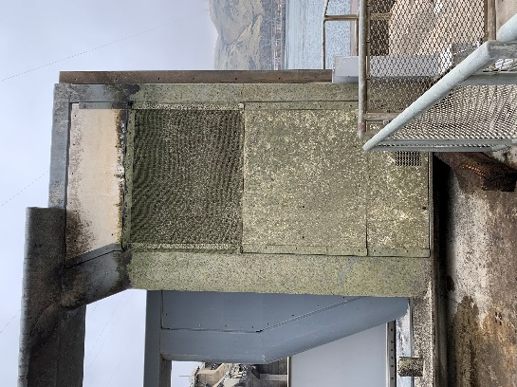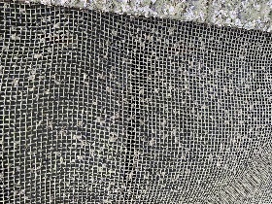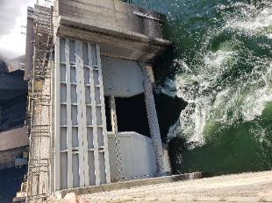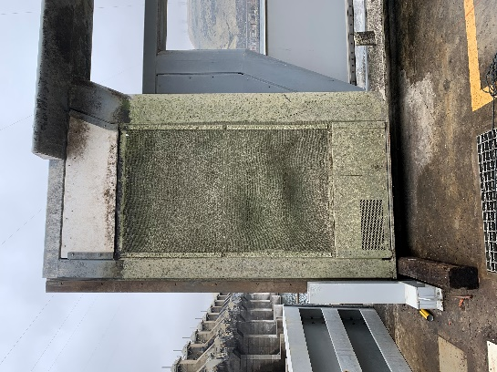

## Project Schedule

Design: FY 2021

Construction: Winter 2021/2022

Evaluation/Closeout: FY 2022

## Current Status

VWW is in place with JBS screen panels (as pictured above) awaiting design and fabrication.

## Topics for FFDRWG Review/Coordination

None currently.

Fish Facility Design Review Work Group (FFDRWG)

USACE, Portland District

Project Update

Date Prepared/Updated: 2021-03-30

# JDA North Fish Ladder LPS water supply upgrade

|  |  |
| --- | --- |
| Project Identifier: | P2 # 492402 |
| Project Manager (PM): | Eric Bluhm (CENWP-PM-FP)  *Eric.V.Bluhm@usace.army.mil* |
| Technical Lead (TL): | Adam White (CENWP-ENC)  *Adam.J.White@usace.army.mil* |
| FFDRWG Coordination (FC): | Jacob Macdonald (CENWP-PME)  *Jacob.Macdonald@usace.army.mil* |

## Project Description

Increase the capacity of the current system.

1. Modify LPS to replace existing drop in well pumps with gravity-fed water supply or alternative, more reliable pump configuration.
2. Larger collection box (current water supply is insufficient so larger box cannot be installed without upgraded water supply.
3. Consider opportunities for volitional passage in the design (per 2020 CRS BA § 2.5, pg. 2-85)

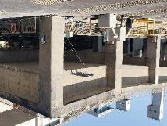 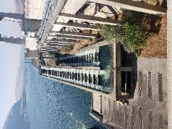 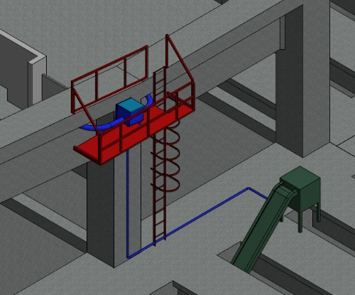

## Project Schedule

Design: FY 2021

Construction: Winter 2021/2022

Evaluation/Closeout: FY 2022

## Current Status

PDT will prepare multiple alternatives for consideration. Internal scoping meeting scheduled for 4/12. LPS is in service for 2021 passage season with existing pumps and collection box.

## Topics for FFDRWG Review/Coordination

None currently.

Fish Facility Design Review Work Group (FFDRWG)

USACE, Portland District

Project Update

Date Prepared/Updated: 2021-05-04

# JDA South Ladder entrance improvements (rounded crest, slot filler)

|  |  |
| --- | --- |
| Project Identifier: | P2 # 492402 |
| Project Manager (PM): | Eric Bluhm (CENWP-PM-FP)  *Eric.V.Bluhm@usace.army.mil* |
| Technical Lead (TL): | Adam White (CENWP-ENC)  *Adam.J.White@usace.army.mil* |
| FFDRWG Coordination (FC): | Jacob Macdonald (CENWP-PME)  *Jacob.Macdonald@usace.army.mil* |

## Project Description

Entrance weir improvements (rounded crest, slot filler). Caps cannot be added to South Ladder entrance weir due to FPP submergence criteria so the weir needs to be modified more extensively to provide rounded weir crests and guide slot covers.

## Project Schedule

* Design: FY2021
* Construction: Winter 2021/2022
* Evaluation/Closeout: FY 2022

## Current Status

Internal scoping meeting occurred on 4/12. PDT kickoff meeting scheduled for 5/17.

## Topics for FFDRWG Review/Coordination

None currently.

Fish Facility Design Review Work Group (FFDRWG)

USACE, Portland District

Project Update

Date Prepared/Updated: 2021-05-04

# TDA East Fish Ladder junction pool LPS

|  |  |
| --- | --- |
| Project Identifier: | P2 # 492403 |
| Project Manager (PM): | Eric Bluhm (CENWP-PM-FP)  *Eric.V.Bluhm@usace.army.mil* |
| Technical Lead (TL): | Adam White (CENWP-ENC)  *Adam.J.White@usace.army.mil* |
| FFDRWG Coordination (FC): | Jacob Macdonald (CENWP-PME)  *Jacob.Macdonald@usace.army.mil* |

## Project Description

Design junction pool LPS to tailrace deck collection box.

“Expand network of Lamprey Passage Structures (LPSs) to bypass impediments in existing fish ladders **(Lamprey Passage Structures)**. Ramp-like flume structures would be installed or modified in fish ladders at Bonneville, The Dalles, and John Day dams to guide adult lamprey out of fish ladders and into parallel systems for volitional passage or collection for upstream transport or passage studies. The LPSs would use independent water sources (pumps or gravity flow

systems) and may be placed in various locations within fish ladders, such as collection channels, junction pools, and auxiliary water supply channels. New structures may be installed at Bonneville Dam’s Bradford Island and Washington Shore fish ladders, The Dalles Dam’s east fish ladder, and/or John Day Dam’s south fish ladder. At John Day Dam, the existing lamprey passage structure on the north fish ladder may be extended from the tailrace deck to the forebay” ***-January 2020 CRS BA § 2.5, pg. 2-85****.*

## Project Schedule

* Design: FY 2021 – FY 2022
* Construction: Winter 2022/2023
* Evaluation/Closeout: FY 2023

## Current Status

New startup. Internal scoping meeting occurred 4/21. PDT kickoff meeting scheduled for 5/20.

## Topics for FFDRWG Review/Coordination

None currently.

Fish Facility Design Review Work Group (FFDRWG)

USACE, Portland District

Project Update

Date Prepared/Updated: 2021-05-04

# TDA East Fish Ladder control section weir modifications for lamprey

|  |  |
| --- | --- |
| Project Identifier: | P2 # 492403 |
| Project Manager (PM): | Eric Bluhm (CENWP-PM-FP)  *Eric.V.Bluhm@usace.army.mil* |
| Technical Lead (TL): | Adam White (CENWP-ENC)  *Adam.J.White@usace.army.mil* |
| FFDRWG Coordination (FC): | Jacob Macdonald (CENWP-PME)  *Jacob.Macdonald@usace.army.mil* |

## Project Description

Modify elevated orifices in East Fish Ladder control section weirs 154-157 for better adult lamprey passage.

## Project Schedule

* Design: FY 2022
* Construction: Winter 2022/2023
* Evaluation/Closeout: FY 2023

## Current Status

## New startup. Internal scoping meeting occurred 4/21. PDT kickoff meeting scheduled for 5/20.

## Topics for FFDRWG Review/Coordination

None currently.

Fish Facility Design Review Work Group (FFDRWG)

USACE, Portland District

Project Update

Date Prepared/Updated: 2021-03-30

# BON Lamprey Passage Structure Pump Upgrade

|  |  |
| --- | --- |
| Project Identifier: | P2 # 492400 (BON1) and 492401 (BON2) |
| Project Manager (PM): | Bob Winters (CENWP-PM-FP)  *Robert.Winters@usace.army.mil* |
| Technical Lead (TL): | Andrew Derugin (CENWP-ODB)  *Andrew.G.Derugin@usace.army.mil* |
| FFDRWG Coordination (FC): | Andrew Derugin (CENWP-PME)  *Andrew.G.Derugin@usace.army.mil* |

## Project Description

Bradford Island, Cascades Island, and Washington Shore LPS's will have current drop in well pumps replaced with standardized 480V surface mount pumps that will increase the reliability and flexibility of the Bonneville Dam LPS system.

## Project Schedule

* Acquire Materials: FY 2021
* Installation: WA Shore and Cascades Island – FY 2021, Bradford Island – Winter 2021/2022
* Evaluation/Closeout: FY 2022

## Current Status

New pumps have been installed at the Washington Shore LPS, tested on 29-Apr.

## Topics for FFDRWG Review/Coordination

None currently.

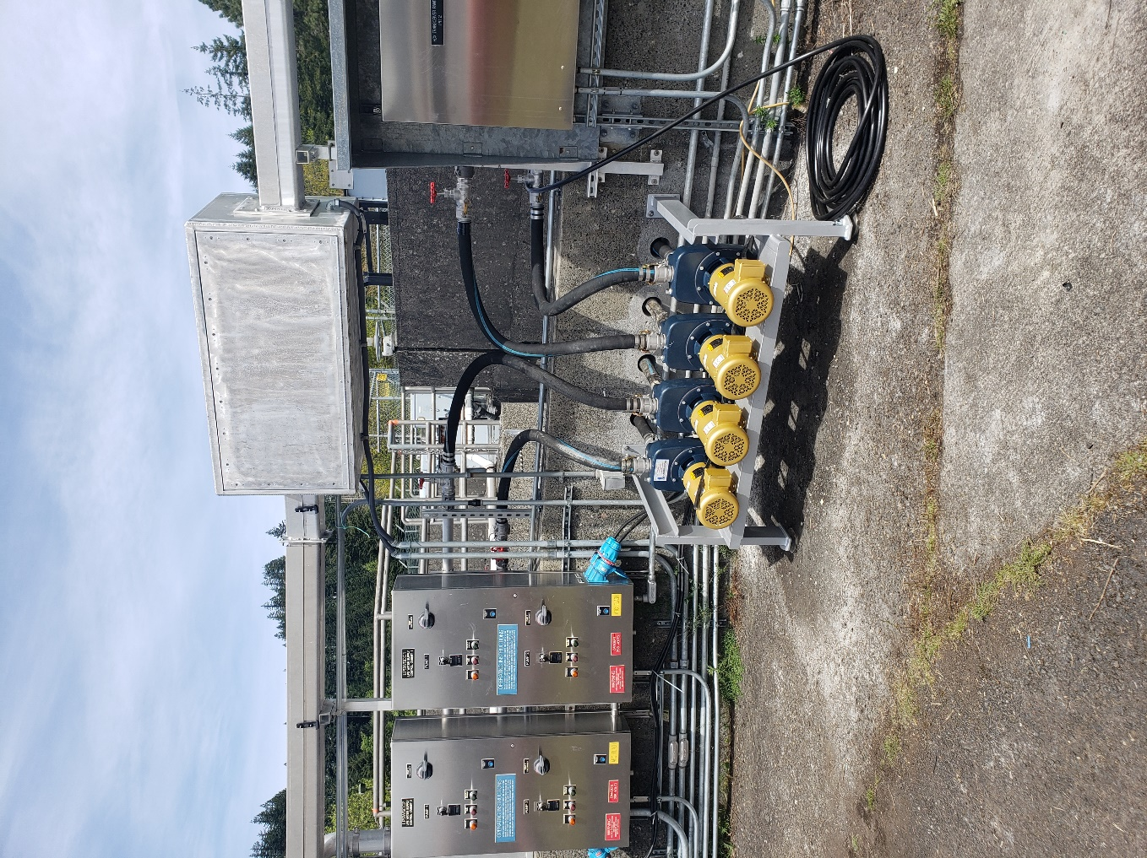Newly installed Washington Shore LPS pumps (4/29/2021)

Fish Facility Design Review Work Group (FFDRWG)

USACE, Portland District

Project Update

Date Prepared/Updated: 2021-03-31

# BON Bradford Island B-Branch entrance improvements (variable width entrance weir, bollards, and transition pool LPS)

|  |  |
| --- | --- |
| Project Identifier: | P2 # 492400 |
| Project Manager (PM): | Bob Winters (CENWP-PM-FP)  *Robert.Winters@usace.army.mil* |
| Technical Lead (TL): | Adam White (CENWP-ENC)  *Adam.J.White@usace.army.mil* |
| FFDRWG Coordination (FC): | Andrew Derugin (CENWP-PME)  *Andrew.G.Derugin@usace.army.mil* |

## Project Description

Design B-Branch (Spillway) entrance improvements, including variable width weir, bollards, refuge boxes or other cover, as feasible. Implement in conjunction with transition pool LPS at this fishway.

* Modeled after Cascades Island and JDA North (mirror image of Cascades Island Entrance)

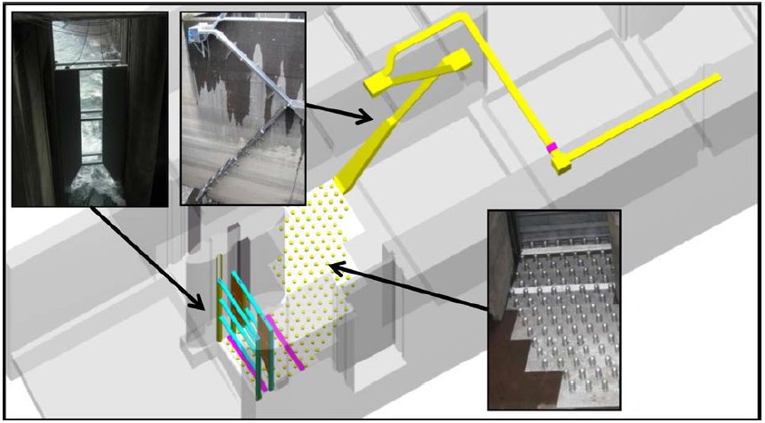

*Cascades Island entrance improvements (2009)*

## Project Schedule

TBD

## Current Status

Internal scoping meeting scheduled for 4/8.

## Topics for FFDRWG Review/Coordination

None currently.

Fish Facility Design Review Work Group (FFDRWG)

USACE, Portland District

Project Update

Date Prepared/Updated: 2021-03-03

# BON Bradford Island Ladder extensive minor modifications to serpentine section for lamprey

|  |  |
| --- | --- |
| Project Identifier: | P2 # 492400 |
| Project Manager (PM): | Bob Winters (CENWP-PM-FP)  *Robert.Winters@usace.army.mil* |
| Technical Lead (TL): | Adam White (CENWP-ENC)  *Adam.J.White@usace.army.mil* |
| FFDRWG Coordination (FC): | Andrew Derugin (CENWP-PME)  *Andrew.G.Derugin@usace.army.mil* |

## Project Description

Extensive minor modifications to control section (serpentine weirs) of ladder including refuge boxes, rounded corners on weirs, additional lamprey orifices, and (if practicable) new features such as artificial rocks.

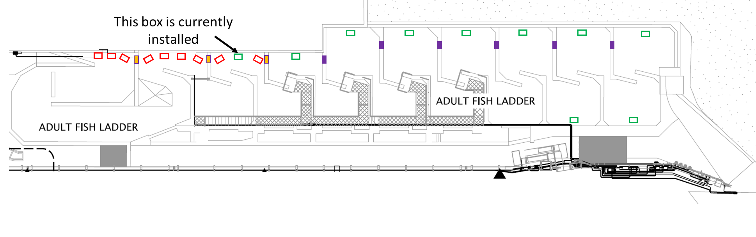 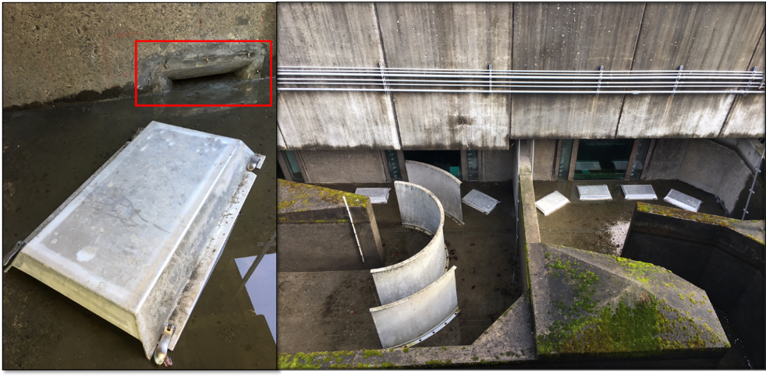

## Project Schedule

TBD

## Current Status

New Startup.

## Topics for FFDRWG Review/Coordination

None currently.

Fish Facility Design Review Work Group (FFDRWG)

USACE, Portland District

Project Update

Date Prepared/Updated: 2021-03-03

# BON Cascades Island LPS Flume modifications

|  |  |
| --- | --- |
| Project Identifier: | P2 # 492401 |
| Project Manager (PM): | Bob Winters (CENWP-PM-FP)  *Robert.Winters@usace.army.mil* |
| Technical Lead (TL): | Adam White (CENWP-ENC)  *Adam.J.White@usace.army.mil* |
| FFDRWG Coordination (FC): | Andrew Derugin (CENWP-PME)  *Andrew.G.Derugin@usace.army.mil* |

## Project Description

Lamprey flume needs to be lowered to eliminate the mid-system lift pumps. This may require rerouting existing plumbing and moving electrical equipment in the area, as well as fabricating new brackets and a new flume section.

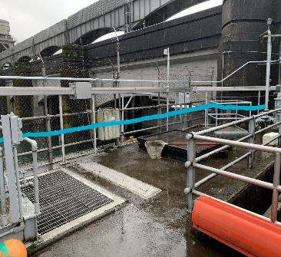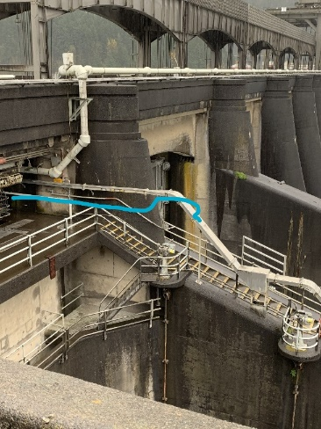

## Project Schedule

* Design: FY 2021
* Construction: August 2021
* Evaluation and Closeout: FY 2022

## Current Status

Initiating design.

## Topics for FFDRWG Review/Coordination

None currently.

Fish Facility Design Review Work Group (FFDRWG)

USACE, Portland District

Project Update

Date Prepared/Updated: 2021-03-30

# BON Cascades Island upper picketed lead modification

|  |  |
| --- | --- |
| Project Identifier: | P2 # 492401 |
| Project Manager (PM): | Bob Winters (CENWP-PM-FP)  *Robert.Winters@usace.army.mil* |
| Technical Lead (TL): | Andrew Derugin (CENWP-ODB)  *Andrew.G.Derugin@usace.army.mil* |
| FFDRWG Coordination (FC): | Andrew Derugin (CENWP-PME)  *Andrew.G.Derugin@usace.army.mil* |

## Project Description

Modify two upper picket leads (upstream of new LPS trap) to exclude lamprey from AWS Channel. Replace existing leads with smaller mesh and eliminate gaps to prevent lamprey from straying into the dead-end abandoned AWS channel.

## Project Schedule

* Installation: FY 2021
* Evaluation/Closeout: FY 2021

## Current Status

OD-B project staff are scheduled to perform this minor modification Spring 2021.

## Topics for FFDRWG Review/Coordination

None currently.

Fish Facility Design Review Work Group (FFDRWG)

USACE, Portland District

Project Update

Date Prepared/Updated: 2021-03-31

# BON Washington Shore junction pool LPS

|  |  |
| --- | --- |
| Project Identifier: | P2 # 492401 |
| Project Manager (PM): | Bob Winters (CENWP-PM-FP)  *Robert.Winters@usace.army.mil* |
| Technical Lead (TL): | Adam White (CENWP-ENC)  *Adam.J.White@usace.army.mil* |
| FFDRWG Coordination (FC): | Andrew Derugin (CENWP-PME)  *Andrew.G.Derugin@usace.army.mil* |

## Project Description

Design Transition Pool LPS to tailrace deck collection box. Include refuge boxes or bollards to guide lamprey to new structure.

“Expand network of Lamprey Passage Structures (LPSs) to bypass impediments in existing fish ladders **(Lamprey Passage Structures)**. Ramp-like flume structures would be installed or modified in fish ladders at Bonneville, The Dalles, and John Day dams to guide adult lamprey out of fish ladders and into parallel systems for volitional passage or collection for upstream transport or passage studies. The LPSs would use independent water sources (pumps or gravity flow

systems) and may be placed in various locations within fish ladders, such as collection channels, junction pools, and auxiliary water supply channels. New structures may be installed at Bonneville Dam’s Bradford Island and Washington Shore fish ladders, The Dalles Dam’s east fish ladder, and/or John Day Dam’s south fish ladder. At John Day Dam, the existing lamprey passage structure on the north fish ladder may be extended from the tailrace deck to the forebay”

***-January 2020 CRS BA § 2.5, pg. 2-85****.*

## Project Schedule

* Design: FY 2021 – FY 2022
* Construction: Winter 2022/2023
* Evaluation/Closeout: FY 2023

## Current Status

New Startup.

## Topics for FFDRWG Review/Coordination

None currently.

Fish Facility Design Review Work Group (FFDRWG)

USACE, Portland District

Project Update

Date Prepared/Updated: 2021-03-30